Roles

So far, we learned how Ansible can interact with configured clients from the command line with the **ansible** command, and how we can automate configuration with playbooks run through the **ansible-playbook** command.

We can use two techniques for reusing a set of tasks: **includes** and **roles**.

**Roles** are good for organizing Tasks and encapsulating data needed to accomplish those Tasks.

For example, to install Nginx, we need to add a package repository, install the package and set up configuration. We've installed Nginx using a Playbook, but as we add more functionality to our Playbook, they can become difficult to maintain as a single file. **Roles allow us to create very minimal playbooks** that then look to a directory structure to determine the configuration steps they need to perform.

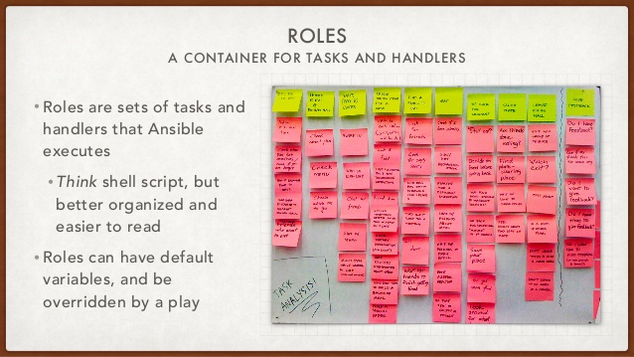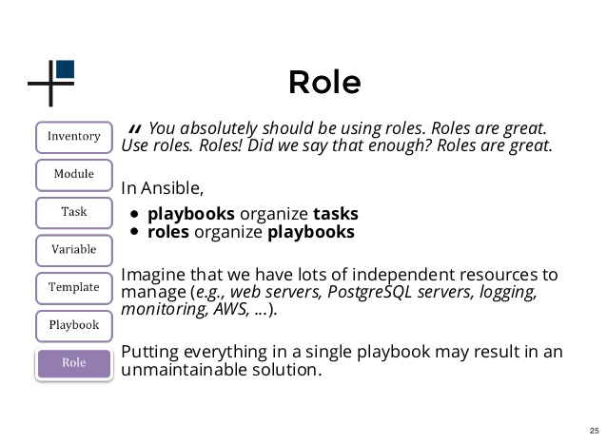

Role directory structure

In order for Ansible to correctly handle roles, we should build a directory structure so that Ansible can find and understand. We can do this by creating a Roles directory in our working directory.

The directory structure for Roles looks like this:

rolename

- files

- handlers

- meta

- templates

- tasks

- vars

A role's directory structure consists of **files**, **handlers**, **meta**, **templates**, **tasks**, and **vars**.

These are the directories that will contain all of the code to implement our configuration. We may not use all of the directories, so in real practice, we may not need to create all of these directories.

1. **files**: This directory contains regular files that need to be transferred to the hosts you are configuring for this role. This may also include script files to run.
2. **handlers**: All handlers that were in your playbook previously can now be added into this directory.
3. **meta**: This directory can contain files that establish role dependencies. You can list roles that must be applied before the current role can work correctly.
4. **templates**: You can place all files that use variables to substitute information during creation in this directory.
5. **tasks**: This directory contains all of the tasks that would normally be in a playbook. These can reference files and templates contained in their respective directories without using a path.
6. **vars**: Variables for the roles can be specified in this directory and used in your configuration files.

main.yml - tasks

Ansible will search for and read any yaml file called **roles/nginx/tasks/main.yml** automatically.

We'll reorganize our nginx.yml file and put each component within the corresponding directory to create a cleaner set.

Here is our current **nginx.yml**:

---

- hosts: aws

tasks:

- name: Installs Nginx

apt: pkg=nginx state=installed update_cache=true

notify:

- Start Nginx

- name: Upload default index.php for host

copy: src=static_files/index.php dest=/usr/share/nginx/html/ mode=0644

register: php

ignore_errors: True

- name: Remove index.html for host

command: rm /usr/share/nginx/html/index.html

when: php|success

- name: Upload default index.html for host

copy: src=static_files/index.html dest=/usr/share/nginx/html/ mode=0644

when: php|failed

handlers:

- name: Start Nginx

service: name=nginx state=started

If we run **ansible-playbook**:

$ ansible-playbook -s nginx.yml -u ubuntu

PLAY [aws] ********************************************************************

GATHERING FACTS ***************************************************************

ok: [54.153.20.237]

TASK: [Installs Nginx] ********************************************************

ok: [54.153.20.237]

TASK: [Upload default index.php for host] *************************************

changed: [54.153.20.237]

TASK: [Remove index.html for host] ********************************************

changed: [54.153.20.237]

TASK: [Upload default index.html for host] ************************************

skipping: [54.153.20.237]

PLAY RECAP ********************************************************************

54.153.20.237 : ok=4 changed=2 unreachable=0 failed=0

We only want to keep the lines of tasks. Also, we can remove the extraneous spaces to the left of our tasks. After our changes, our new **tasks/main.yml** file will look like this:

---

- name: Installs Nginx

apt: pkg=nginx state=installed update_cache=true

notify:

- Start Nginx

- name: Upload default index.php for host

copy: src=index.php dest=/usr/share/nginx/html/ mode=0644

register: php

ignore_errors: True

- name: Remove index.html for host

command: rm /usr/share/nginx/html/index.html

when: php|success

- name: Upload default index.html for host

copy: src=index.html dest=/usr/share/nginx/html/ mode=0644

when: php|failed

As we can see, the file just lists the steps that are to be performed, which makes it reads well.

We also made a change how we references external files in our configuration. Our src lines reference a **static_files** directory. This is unnecessary if we place all of our static files in the **files** subdirectory. Ansible will find them automatically.

main.yml - handlers

Now that we have the task portion of the playbook in the **tasks/main.yml** file, we need to move the handlers section into a file located at **handlers/main.yml**.

- name: Start Nginx

service: name=nginx state=started

files directory

Move **index.html** and **index.php** pages out of the **static_files** directory and put them into the **roles/nginx/files** directory.

playbook

Outside of the entire role structure, in our working directory, we can create a playbook file, **play.yml**:

---

- hosts: aws

roles:

- role: nginx

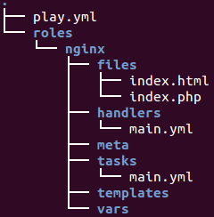

Time to run **ansible-playbook**:

$ ansible-playbook -s play.yml -u ubuntu

PLAY [aws] ********************************************************************

GATHERING FACTS ***************************************************************

ok: [54.153.20.237]

TASK: [nginx | Installs Nginx] ************************************************

ok: [54.153.20.237]

TASK: [nginx | Upload default index.php for host] *****************************

ok: [54.153.20.237]

TASK: [nginx | Remove index.html for host] ************************************

changed: [54.153.20.237]

TASK: [nginx | Upload default index.html for host] ****************************

skipping: [54.153.20.237]

PLAY RECAP ********************************************************************

54.153.20.237 : ok=4 changed=1 unreachable=0 failed=0